1)

1) Convert the following algorithm into a program and find its time complexity using the counter method. void function (int n)
{ int i= 1;
int s =1; while(s <= n)
{ i++; s += i;
}
}
Note: No need of counter increment for declarations and scanf() and count variable printf() statements. Input:
A positive Integer n
Output:
Print the value of the counter variable

For example:
Input | Result
9 | 12
Answer:(penalty regime: 0 %)

#include <stdio.h> int main()
{ int n; int count = 0;

scanf("%d", &n);

int i = 1; count++;

int s = 1; count++;

while (s <= n)
{
count++;
i++;
count++;
s = s + i; count++;
}

count++;

printf("%d", count);

return 0;
}
 | Input | Expected | Got
 | 9 | 12 | 12
 | 4 | 9 | 9
Passed all tests!

Correct

Marks for this submission: 1.00/1.00

2)
Convert the following algorithm into a program and find its time complexity using the counter method. void func(int n)
{
if(n==1) {
printf("*");
} else {
for(int i=1; i<=n; i++)
{
for(int j=1; j<=n; j++)
{ printf("*"); printf("*"); break;
}
}
}
}

Note: No need of counter increment for declarations and scanf() and count variable printf() statements.
Input:
A positive Integer n
Output:
Print the value of the counter variable

#include <stdio.h>

int main()
{ int n; int count = 1;

scanf("%d", &n);

if (n == 1)
{
count++;
} else
{

for (int i = 1; i <= n; i++)
{ count ++;
for (int j = 1; j <= n; j++)
{ count++; count++; count++;
break;
}
count++;
}
count++;
}

printf("%d", count);

return 0;
}
Input | Expected | Got
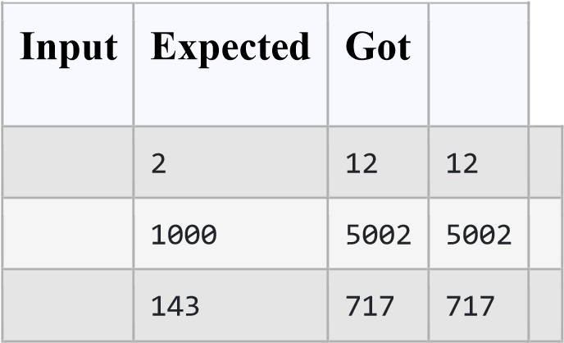
Passed all tests!

3)
Convert the following algorithm into a program and find its time complexity using counter method. Factor(num) {
{
for (i = 1; i <= num;++i)
{
if (num % i== 0)
{
printf("%d ", i);
}
}
}

Note: No need of counter increment for declarations and scanf() and counter variable printf() statement. Input:
A positive Integer n
Output:
Print the value of the counter variable

Answer:

#include <stdio.h>

int main()
{ int n, i;
int count = 0;

scanf("%d", &n);

for (i = 1; i <= n; ++i)
{
count++; count++;

if (n % i == 0)
{
count++;
}
}

count++;

printf("%d", count);

return 0;
}

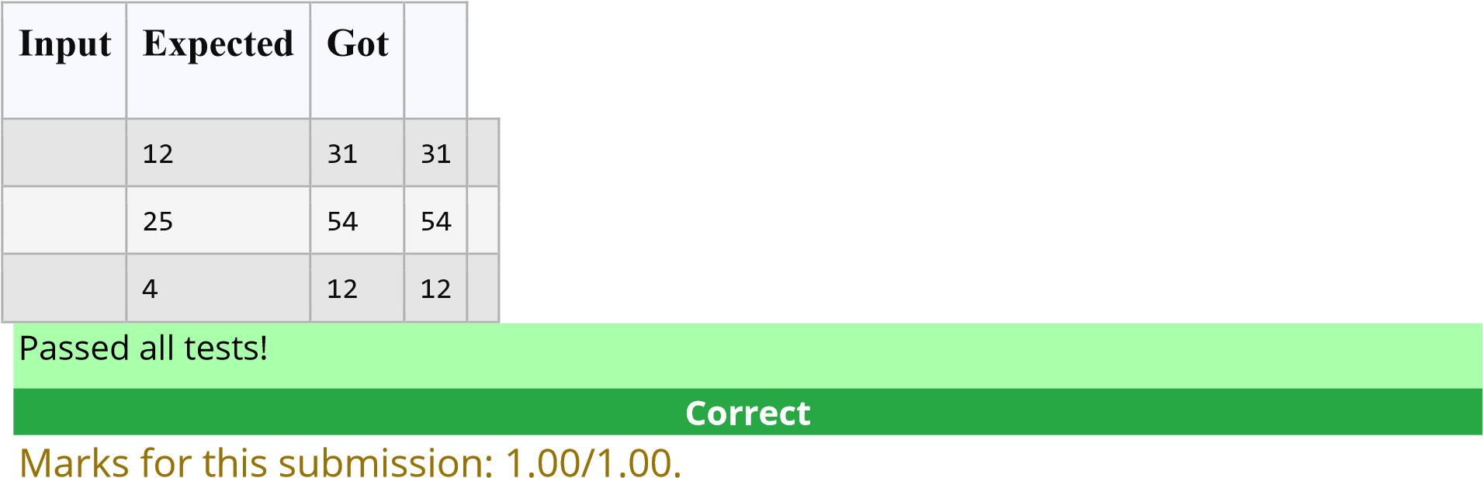
4)
Convert the following algorithm into a program and find its time complexity using counter method.
void function(int n)
{ int c= 0; for(int i=n/2; i<n; i++) for(int j=1; j<n; j = 2 * j) for(int k=1; k<n; k = k * 2) c++;
}

Note: No need of counter increment for declarations and scanf() and count variable printf() statements. Input:
A positive Integer n
Output:
Print the value of the counter variable

Answer:
#include <stdio.h>

int main()
{
int n, i, j, k; int c = 2; scanf("%d", &n);

for (i = n / 2; i < n; i++)
{
c += 2;

for (j = 1; j < n; j = 2 * j)
{
c += 2;

for (k = 1; k < n; k = k * 2)
{
c += 2;
}
}
}

printf("%d", c);

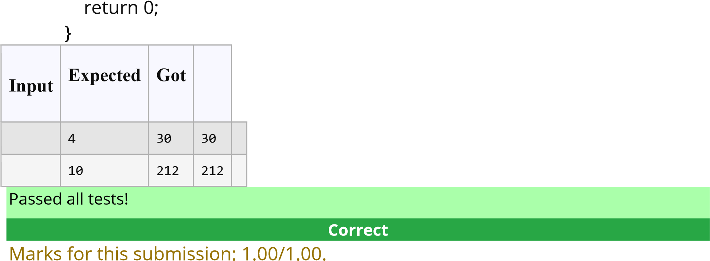
5)
Convert the following algorithm into a program and find its time complexity using counter method.
void reverse(int n)
{ int rev = 0, remainder; while (n != 0)
{
remainder = n % 10; rev = rev * 10 + remainder;
n/= 10;
} print(rev);
}

Note: No need of counter increment for declarations and scanf() and count variable printf() statements.
Input:
A positive Integer n
Output:
Print the value of the counter variable

Answer:
#include <stdio.h> int main() { int n; int c = 0; scanf("%d", &n); int rev = 0, remainder; c++; while (n != 0) { c++; remainder = n % 10; c++;
rev = rev * 10 + remainder; c++; n /= 10; c++;
} c++; c++; printf("%d", c);
